- Create a SQL Datamart (Administration -> Advanced Reporting -> Data marts -> Add menu -> Data mart based on SQL)

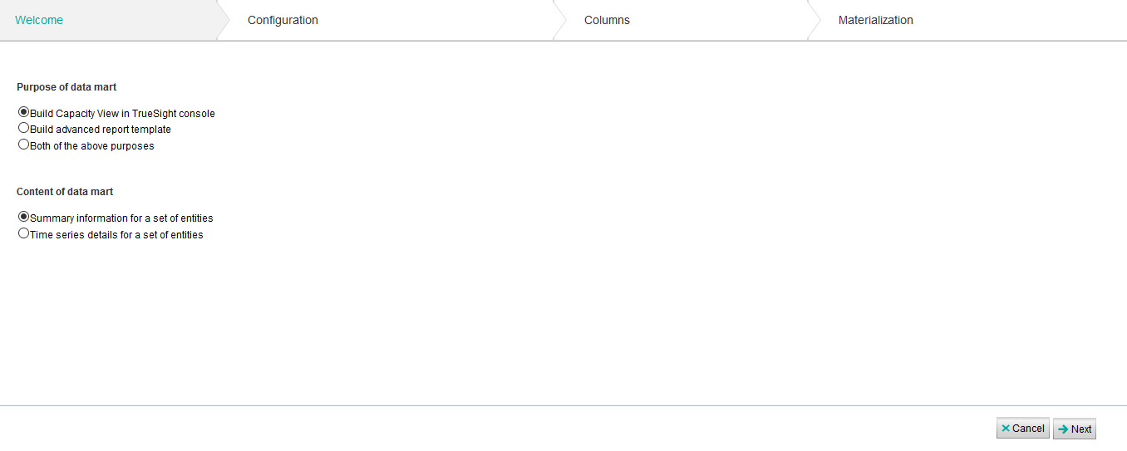
- Give the Datamart a name, description, and enter the SQL query below:
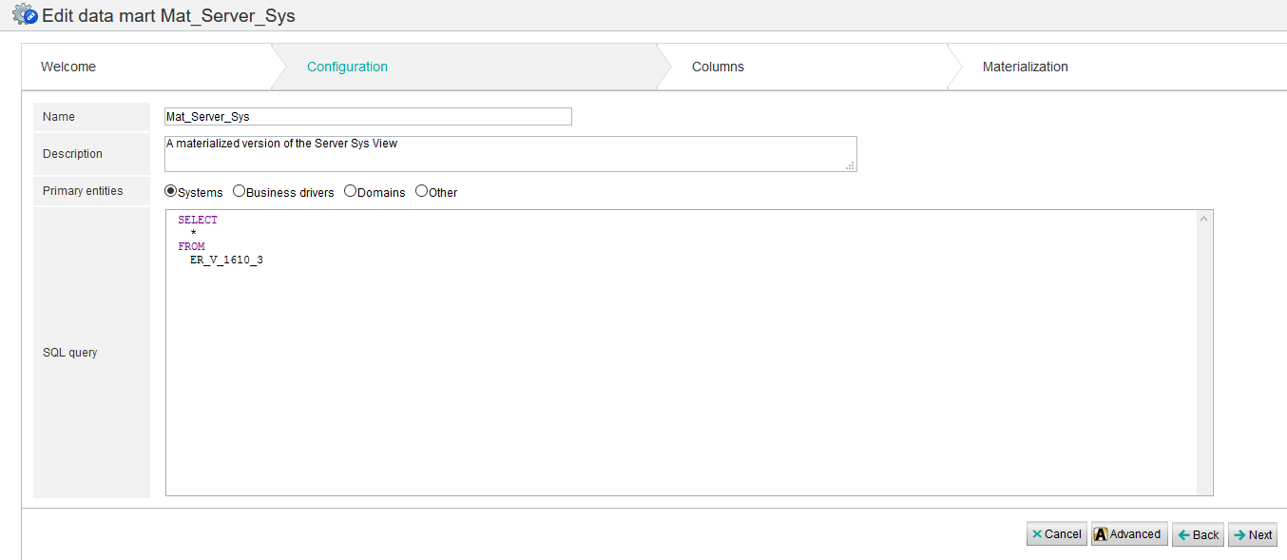

Here is the SQL:
SELECT
*
FROM
ER_V_1610_3
- Edit the ‘entid’ and ‘entname’ output columns and set them as type ‘System Identifer’ and ‘System Name’ respectively. You edit the column by clicking on its name and specifying the meaning.
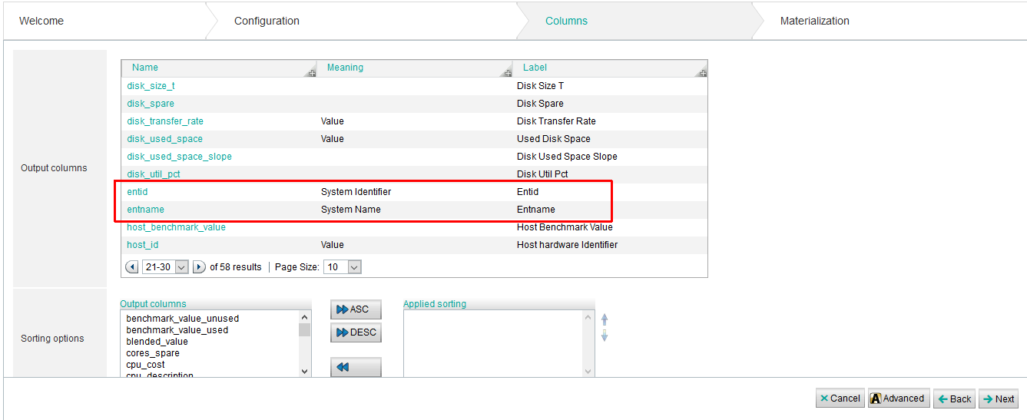
Here is an example of the edit screen for the ‘entid’ metric and what to select:

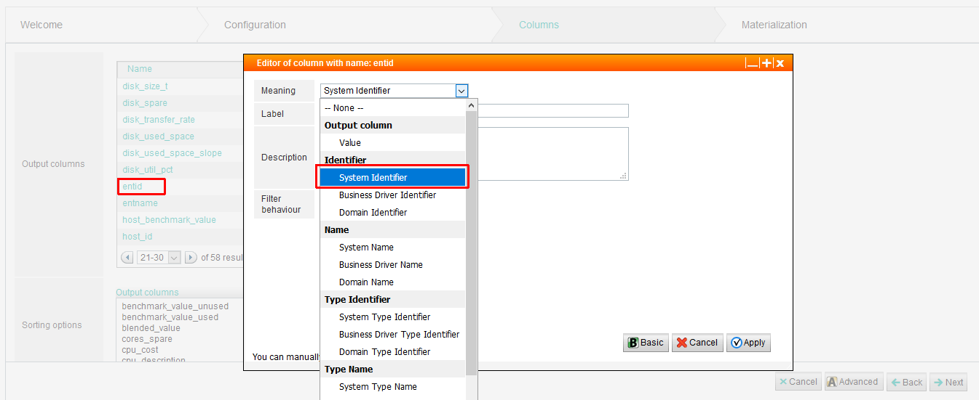

- Select ‘Create a materialized table’ and then assign the Datamart to a Materialization Scheduler (‘Data Mart Materializer’ is the default materializer and is a good selection here).
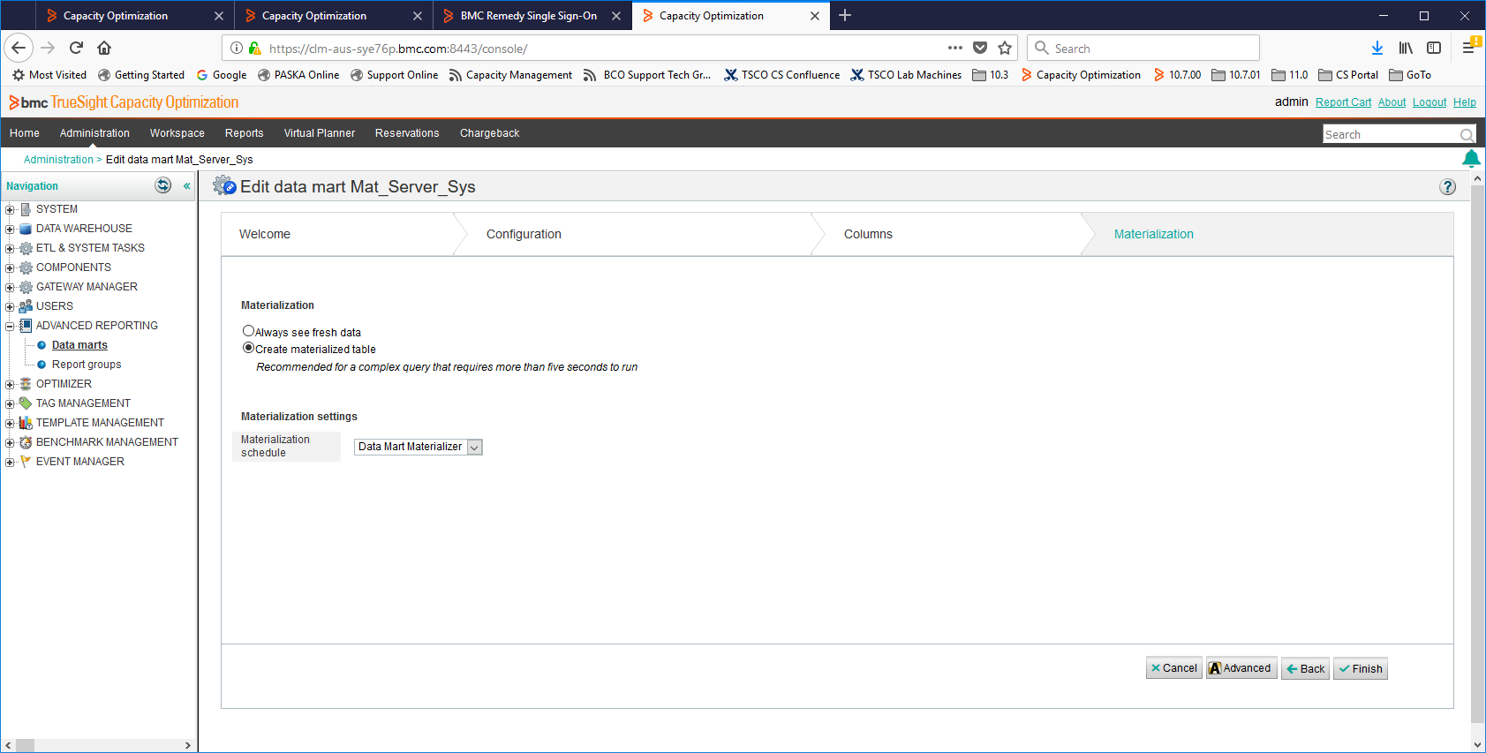

- Now that you’ve created a Materialized Datamart, you can use the following ‘curl’ command run from the command line to access data from it:
Here is a script that will extract the data from the View:
#!/bin/bash

user="admin"
password="admin12345"
hostname="clm-aus-sye76p.bmc.com";

echo "Datamart get data request...";
curl -X GET -k --user $user:$password https://$hostname:8443/dh-services/data/DataMart/2000;
echo;

Where ‘2000’ should be replaced with the ID of the Datamart you created:

That generates output like this:

Datamart get data request...
<?xml version="1.0" encoding="UTF-8"?><CUSTOMSTRUCTURE xmlns:xsi="http://www.w3.org/2001/XMLSchema-instance" version="2.0espaceSchemaLocation="customstructure.xsd"><DATASOURCE COMPONENTID="4" SOURCE="DATAHUB"/><INFO EXTRACTIONDATE="2018-05-18TABLENAME="ER_V_Mat_Server_Sys_2000"><COLUMNS><COLUMN>STRUCTUREID</COLUMN><COLUMN>ENTID</COLUMN><COLUMN>ENTNAME</COLUMN><YPE</COLUMN><COLUMN>CPU_DESCRIPTION</COLUMN><COLUMN>CPU_FAMILY</COLUMN><COLUMN>CPU_MHZ</COLUMN><COLUMN>CPU_MODEL</COLUMN>_MT_TYPE</COLUMN><COLUMN>CPU_NUM</COLUMN><COLUMN>CPU_THREADS_PER_CORE</COLUMN><COLUMN>OS_TYPE</COLUMN><COLUMN>CPU_VENDOR<LUMN>OS_VER</COLUMN><COLUMN>HOST_ID</COLUMN><COLUMN>HW_MODEL</COLUMN><COLUMN>HW_VENDOR</COLUMN><COLUMN>LCPU_NUM</COLUMN><L_REAL_MEM</COLUMN><COLUMN>DISK_SIZE</COLUMN><COLUMN>TOTAL_LDISK_SIZE</COLUMN><COLUMN>CPU_UTIL</COLUMN><COLUMN>MEM_USED</UMN>MEM_UTIL</COLUMN><COLUMN>DISK_USED_SPACE</COLUMN><COLUMN>DISK_PAGING_TO_RATE</COLUMN><COLUMN>DISK_TRANSFER_RATE</COLUNET_BIT_RATE</COLUMN><COLUMN>MEM_REAL_UTIL</COLUMN><COLUMN>TOTAL_FS_UTIL</COLUMN><COLUMN>TOTAL_LDISK_USED</COLUMN><COLUMNLOPE</COLUMN><COLUMN>MEM_UTIL_SLOPE</COLUMN><COLUMN>TOTAL_FS_UTIL_SLOPE</COLUMN><COLUMN>DISK_USED_SPACE_SLOPE</COLUMN><COENCHMARK_VALUE</COLUMN><COLUMN>CPU_COST</COLUMN><COLUMN>MEMORY_COST</COLUMN><COLUMN>STORAGE_COST</COLUMN><COLUMN>CPU_THREMN><COLUMN>MEM_THRESHOLD</COLUMN><COLUMN>STORE_THRESHOLD</COLUMN><COLUMN>CPU_THRESHOLD_GOOD</COLUMN><COLUMN>MEM_THRESHOLDMN><COLUMN>STORE_THRESHOLD_GOOD</COLUMN></COLUMNS></INFO><DATA><![CDATA[SYS;2302;clm-aus-sye76p;Generic;;x86;2194.917;IntR) CPU E5-2698 v4 @ 2.20GHz;;2;;;;;;;;;16658796544;;;1.22;;74.51;;;;;;;;0.01;;;;73.28255;250;150;3;0.85;0.95;0.95;0.75;0.
SYS;2650;clm-aus-syec7d;Virtual Node - VMware;;x86;2194;Intel(R) Xeon(R) CPU E5-2698 v4 @ 2.20GHz;;2;1;Linux;;;;VMware Viorm;VMware, Inc.;2;8203100160.52429;54869590016;;1.69;7955724288.13107;96.98;21351510009.9307;;0;219184;27.04;38.91;;0;0.360938.226082;;250;150;3;0.85;0.95;0.95;0.75;0.9;0.85
SYS;2651;clm-aus-sye76p;Virtual Node - VMware;;x86;2194;Intel(R) Xeon(R) CPU E5-2698 v4 @ 2.20GHz;;2;1;Linux;;;;VMware Viorm;VMware, Inc.;2;16658796543.7379;101306294272.524;4294967296;1.48;11846533120;71.11;17339686633.9795;;0;220008;49.45;16;0.02;20661844.8632529;;250;150;3;0.85;0.95;0.95;0.75;0.9;0.85
]]></DATA></CUSTOMSTRUCTURE>

That output contains the column headings and then contains the data for each of those columns (basically the same output you see in the Datamart when you click the ‘Preview’ button.

