Steps to Run Config Checker Utility and get the result.

Log on to EPD and download the 9.1.00.001 latest config check utility (approx. size 55MB)
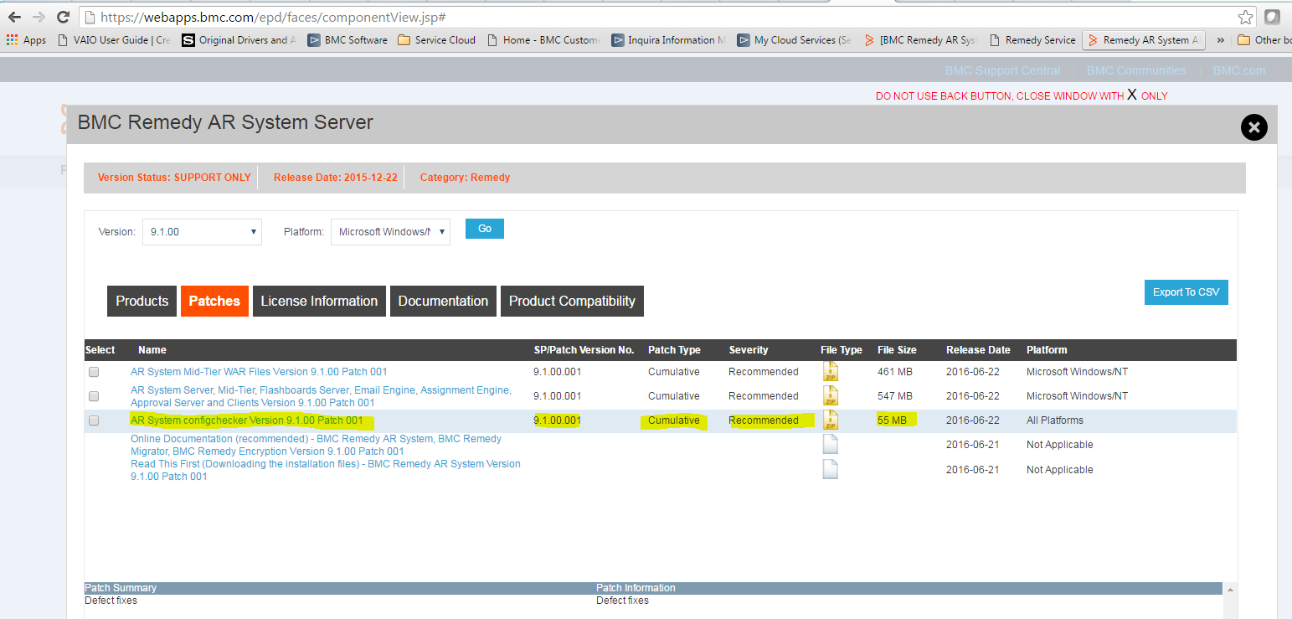

Once downloaded, extract to any location like C or D drive.
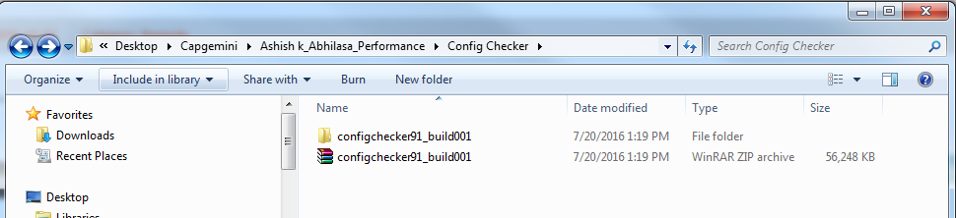

Now open command prompt and navigate to the location where configchecker91_build001 is extracted.
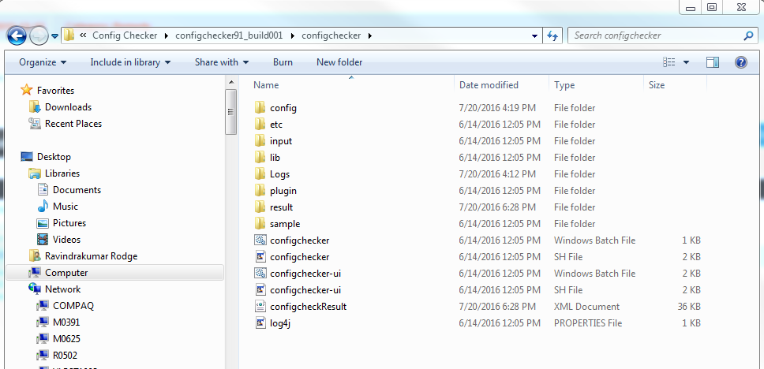

Open command prompt to the same location:
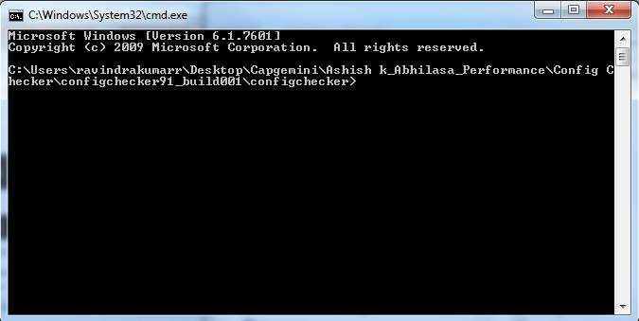

Set JAVA_HOME path as below:
Set JAVA_HOME=C:\Program Files\Java\jre1.8.101
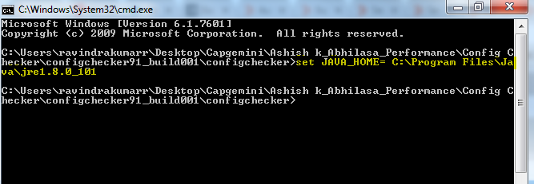

Now Run configchecker-ui.bat from command prompt like below:
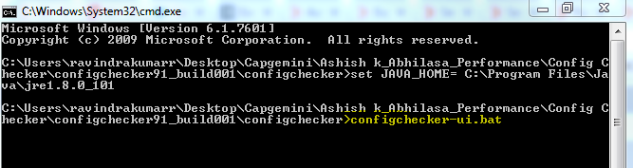
If everything is correct then it will load the utility and will open as below:
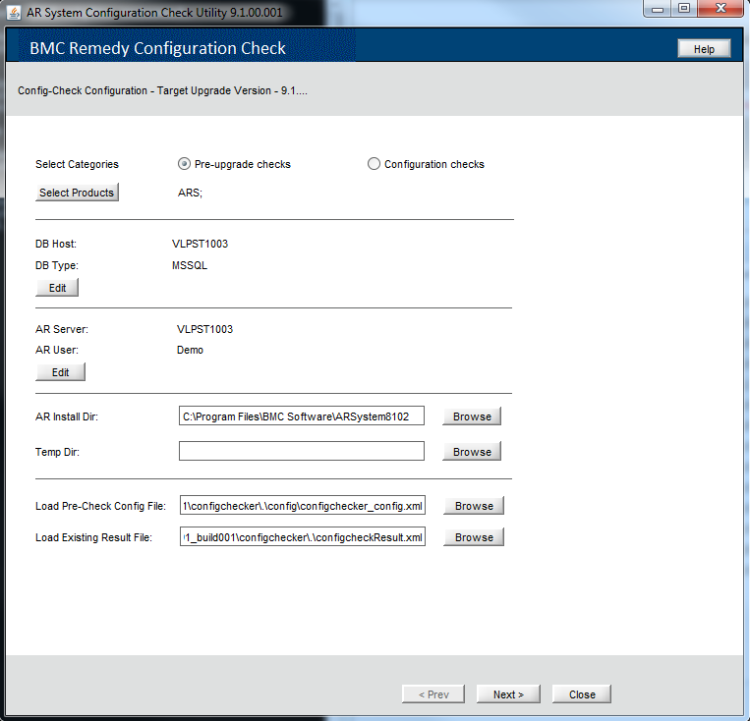

You can run the config checker utility in 2 modes.
- Pre-upgrade checks
- Configuration checks

Select Products: To select what all products needs to be checked.
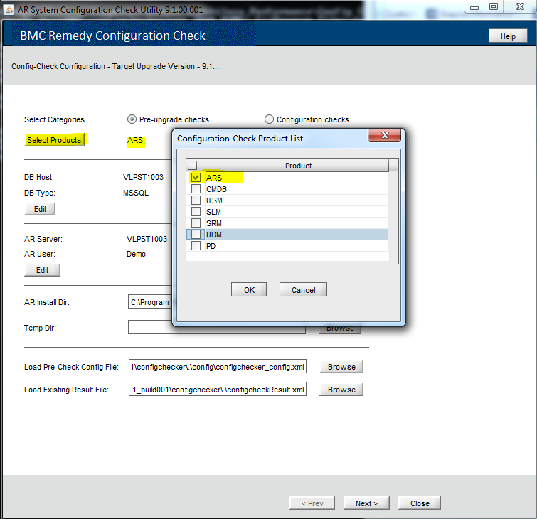

Give the DB connection details where the database is installed and running.
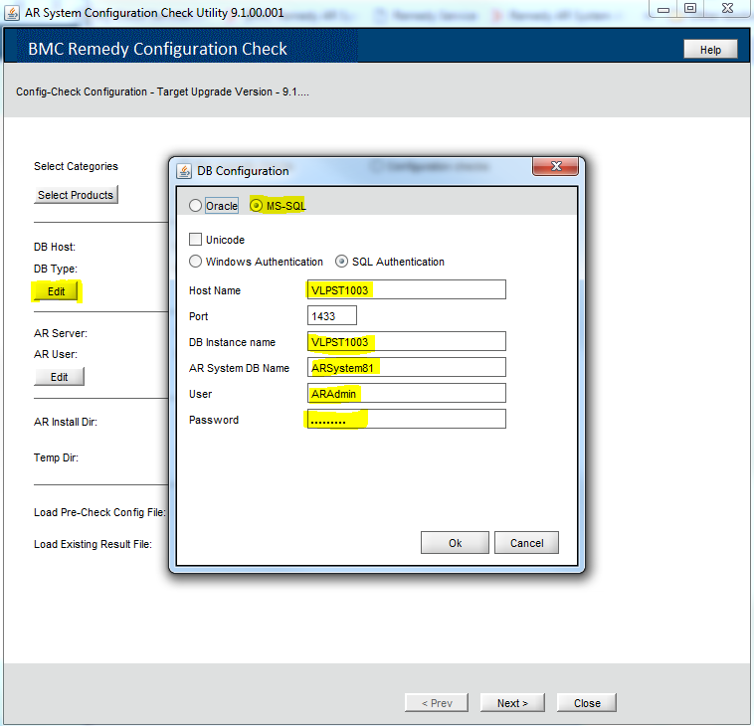

Give AR Server details as below:
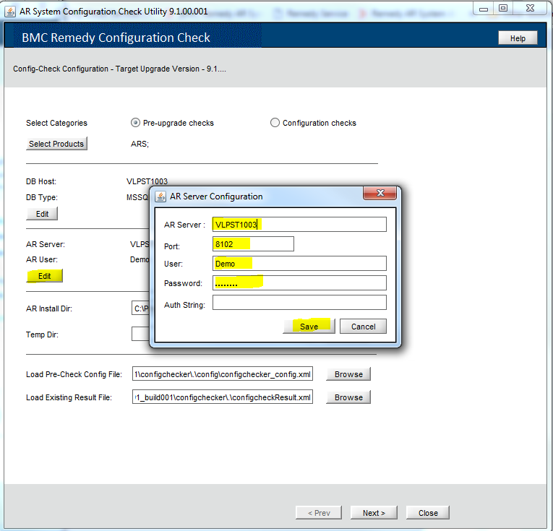
Give AR Install DIr path as location where AR Server is installed.
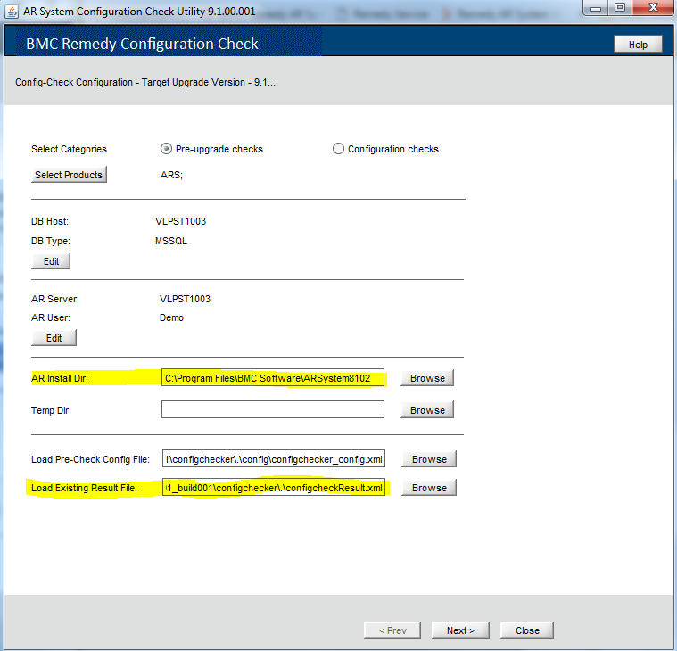
Once done click next>
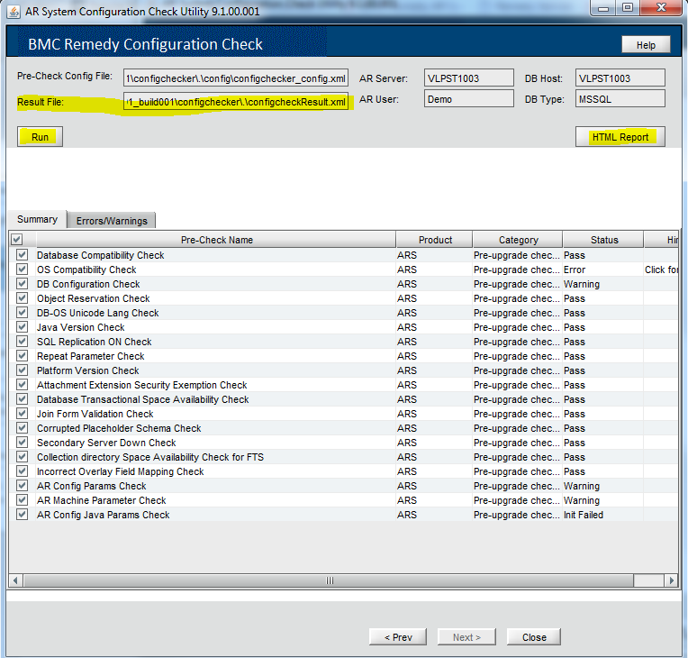
In above screen -> click Run and once the Run is completed click on HTML Reports to get the result in HTML format.

The same result is also available under result folder in config checker utility directory as below.
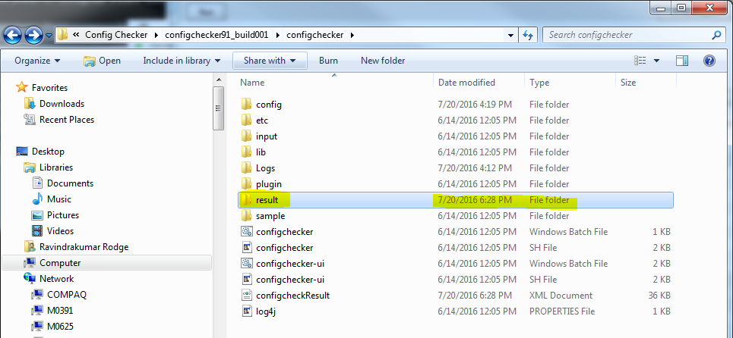

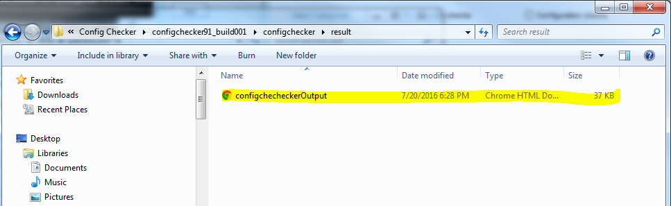

When you open the report it look like below:
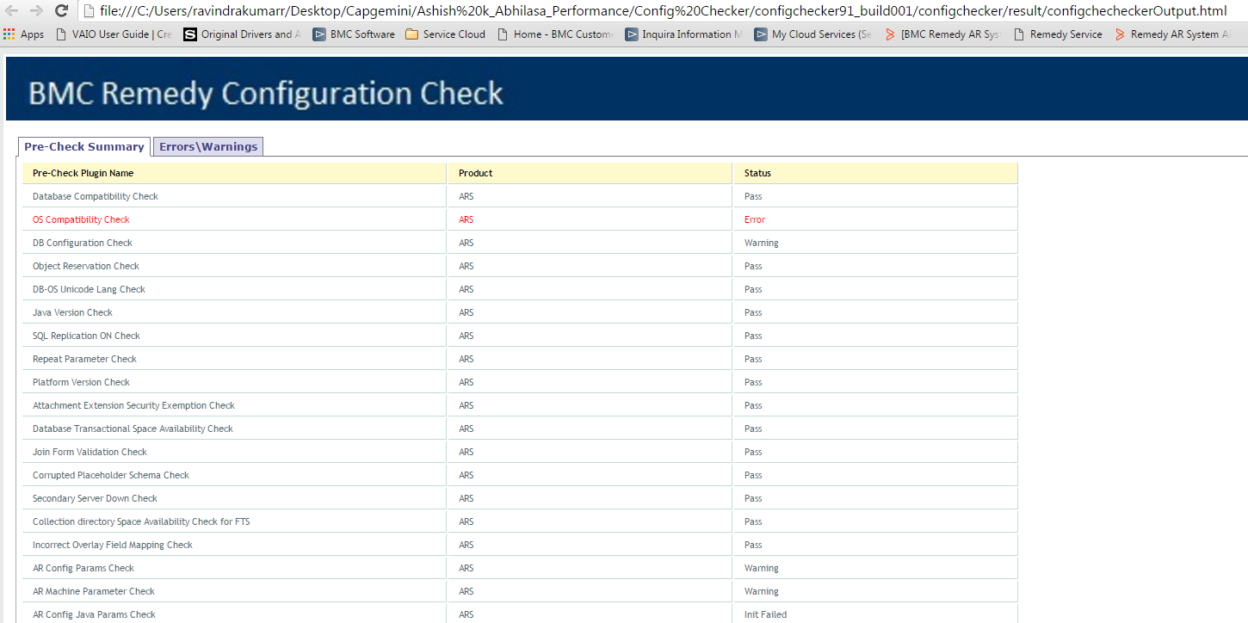

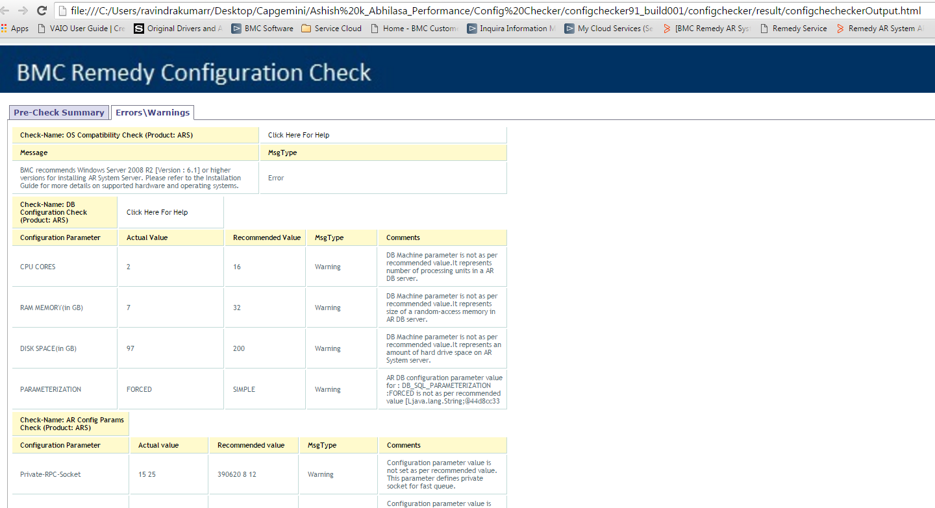

Docs link: https://docs.bmc.com/docs/display/public/brid91/Preupgrade+checks+and+configuration+checks

