Configuration for AR Midtier to enable the Smart Reporting SSL
[Note: As the below steps are the AR Midtier Configuration, this will need AR Midtier Application Server restart]
- Enable Smart Reporting Tomcat App Server with SSL using standard Tomcat SSL Configuration
- Open Browser, navigate to Smart Reporting secured URL, and test SSL works using https://<SR_HostName>:<PORT>
For example: https://10.133.71.251:9443/
- Click on ,
  - View Site Information from URL Address bar Go to Connection Certification Information Details Copy to file Next Select Base-64 encoded X.509 (.CER) Next Provide the Certification name and save .cer file and keep this handy
For example: Reporting.cer
- Go to Midtier tomcat server JAVA location
For example: C:\Program Files\Java\jre1.8.0_65\lib\security
And copy the Reporting.cer collected from step 3 to above location

- Now go to JAVA Directory to execute the Keytool.exe for enabling the trusted keystore between the Reporting and Midtier server,
For example:
  - Open Command Prompt, navigate to C:\Program Files\Java\jre1.8.0_65\bin>
  - Run command C:\Program Files\Java\jre1.8.0_65\bin>keytool -import -keystore "C:\Program Files\Java\jre1.8.0_65\lib\security\cacerts" -file "C:\Program Files\Java\jre1.8.0_65\lib\security\Reporting.cer"
  - Enter password : changeit <default>
  - Once this command run successfully, below results should be observed :
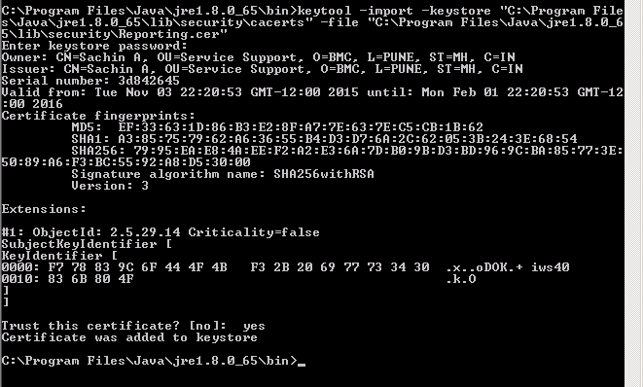
  - Make sure the cacerts file gets modified by checking the Date Modified once the step 5.d went successful
- Go to services and Restart the Midtier tomcat Server
- Make sure the https smart reporting URL is configured in Midtier Report Setting configuration
- Now Navigate to Midtier URL and Launch Smart Reporting Application from Application List , and this should work now

