- Download sap Sybase anywhere 16 client from https://archive.sap.com/documents/docs/DOC-35857 [ SAP SQL Anywhere 16.0 Windows x86 and x64]
- Install on Windows machine or Laptop.
- Run dbisql on cmd prompt
- Once db-editor opened
- Enter your credentials and details as given in below screenshot and press connect button.

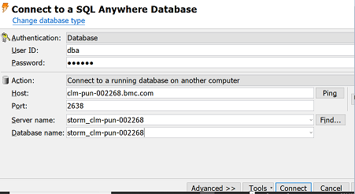

- Follow the ReadMe given in KA for 000107875 [KA414783] using
Stale_partition_sybase.zip

- Once this activity done, please proceed for Rebuild activity.

