Client Gateway Installation & Setup

- Prerequisites:
- Windows or Linux server (x86_64) with minimum 2 CPU & 4 GB Memory (Laptop or Desktop with same configuration will also works for local usage)
- Latest java 64-bit version installed on that server preferable greater than
JDK 1.8.101

- Download client gateway installer version 5.9 from below URL.

For Windows Systems:
https://cdn.kaazing.com/releases/kwic/5.9.4/kwic-5.9.4-windows.zip

For Linux Systems:
https://cdn.kaazing.com/releases/kwic/5.9.4/kwic-5.9.4-linux.tar.gz

- Installation & Setup Procedure for Windows Machine:
Follow below steps to install client gateway software in windows.
- Unzip and extract the setup files into location where you want to save it.

For now example it’s extracted to below location.

C:\Program Files\Kaazing

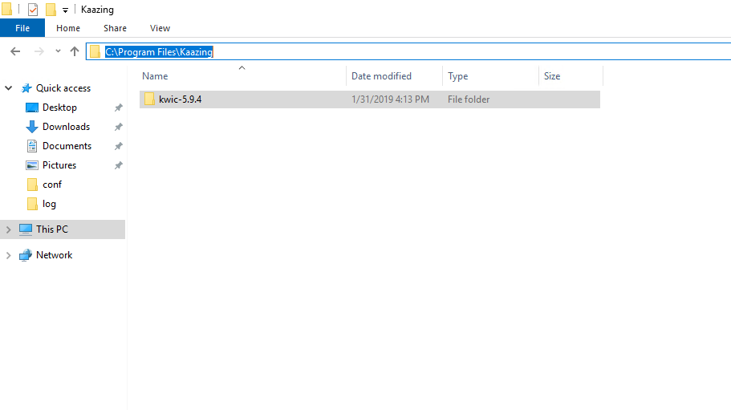

- Go to kwic-5.9.4 folder and you can see below structure of files.

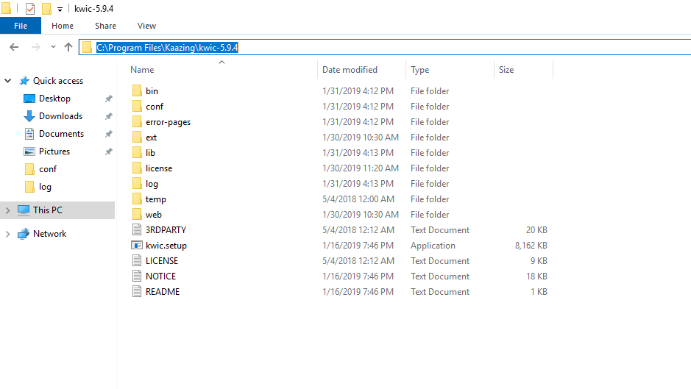

- Open command prompt in administrator mode and run below command

kwic.setup.exe --service

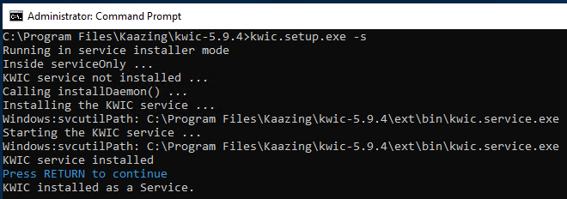

- Above step will install the service in services console. You will see service in services console.

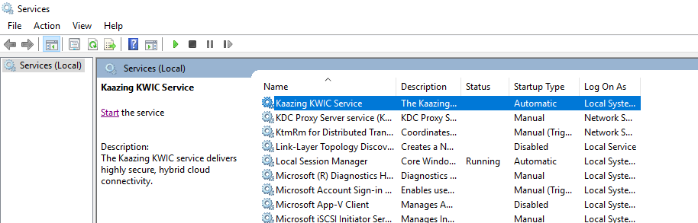

- Once client gateway software is installed on the machine go to the service console and stop client gateway service, which can be found with name “Kaazing KWIC Service”.

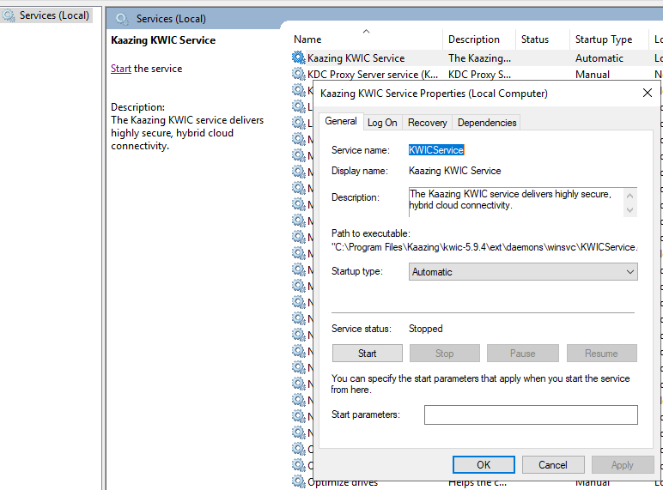

- Go to the gateway config folder and replace the kwic-config.xml file with new kwic-config.xml file provided by BMC Team.

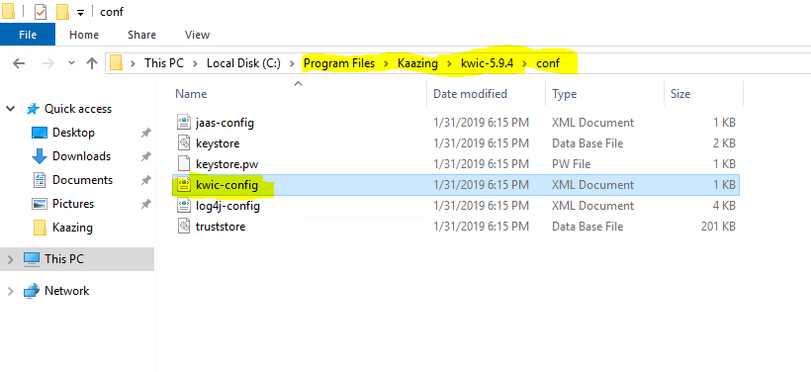

- Start the client gateway service from service console.

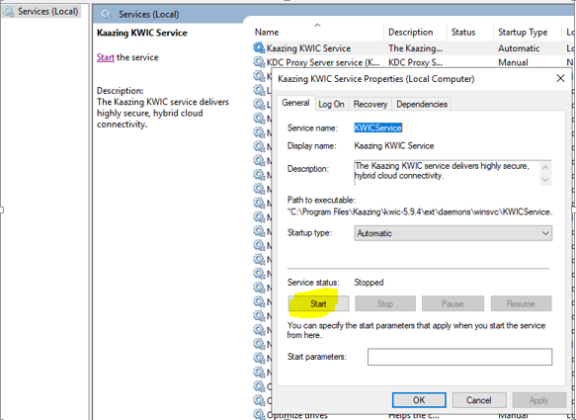

Note: Do clear or backup the logs before restarting the client gateway service. It will help us to troubleshoot the issue if any.

- Installation & Setup Procedure for Linux Machine:

- Download the tar ball from provided link in prerequisites.

- Untar the tarball in the Installation directory.
Cmd # sudo tar –z xvf kwic-5.9.4-linux.tar.gz

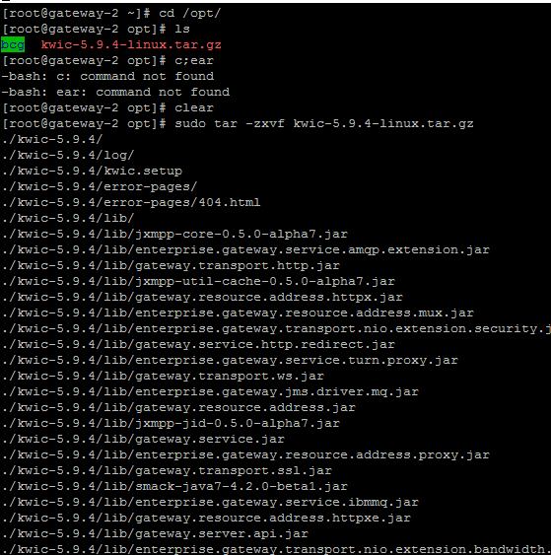

- Below will be the file and folder structure of Kaazing Base directory.

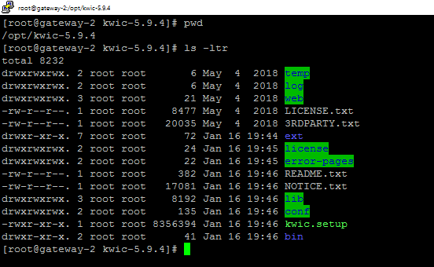

- Replace the kwic-config.xml file from conf directory with new kwic-config.xml file provided by BMC team.
- Go to the gateway bin directory and start the service using below command.

Cmd # sh gateway.start &

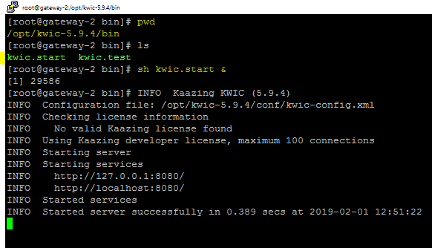

- To stop the service, you will need to find the pid of the service and kill that process forcefully using below command.

Cmd # ps -ef|grep kaazing ( this will find the PID of client gateway process )
Cmd # kill -9 <clinet gateway process PID>

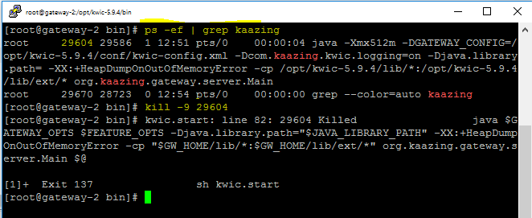

- Installing Kaazing Licenses

1. Login to the Gateway server

2. Stop the Gateway service

3. Delete the all files from license directory (C:\Program Files\Kaazing\kwic-5.9.4\license) and copy the license.xml file to same location

4. Start the Gateway service now

5. Once the gateway service starts successfully, please verify the log (C:\Program Files\Kaazing\kwic-5.9.4\log)and confirm it has picked up the new license file correctly

Log file after update
