Installation and Configuration
The BMC Client Gateway has these basic requirements:
- A Windows server with 2 CPUs and 4 GB of memory (virtualized deployments are acceptable)
- Make sure the windows machine has Java SDK 8, 64 bit
- Network connectivity to the internet on standard HTTPS (TCP port 443)
- Network connectivity to the on-premises applications and servers used for integration
BMC will assist in the customer setup, providing a pre-built configuration file and instructions. Each Customer receives a unique private gateway hostname/URL for connection back to the BMC data center location.
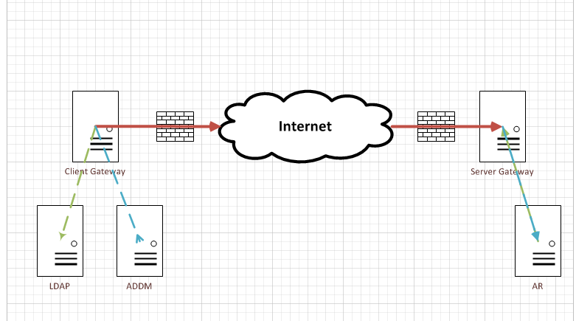

Information needed from Customer requesting BMC Client Gateway connection

Please provide the OnDemand Customer URL:-

OUTBOUND – From BMC OnDemand to Customer
Connection Type | OnDemand Environment  DEV/QA/PROD | On Premise Server IP | On Premise Server hostname | On Premise server Port
Application 1 / ITSM Midtier
Application 2/ AR Server
Application 3 if any
Application 4 if any

