Step #1:
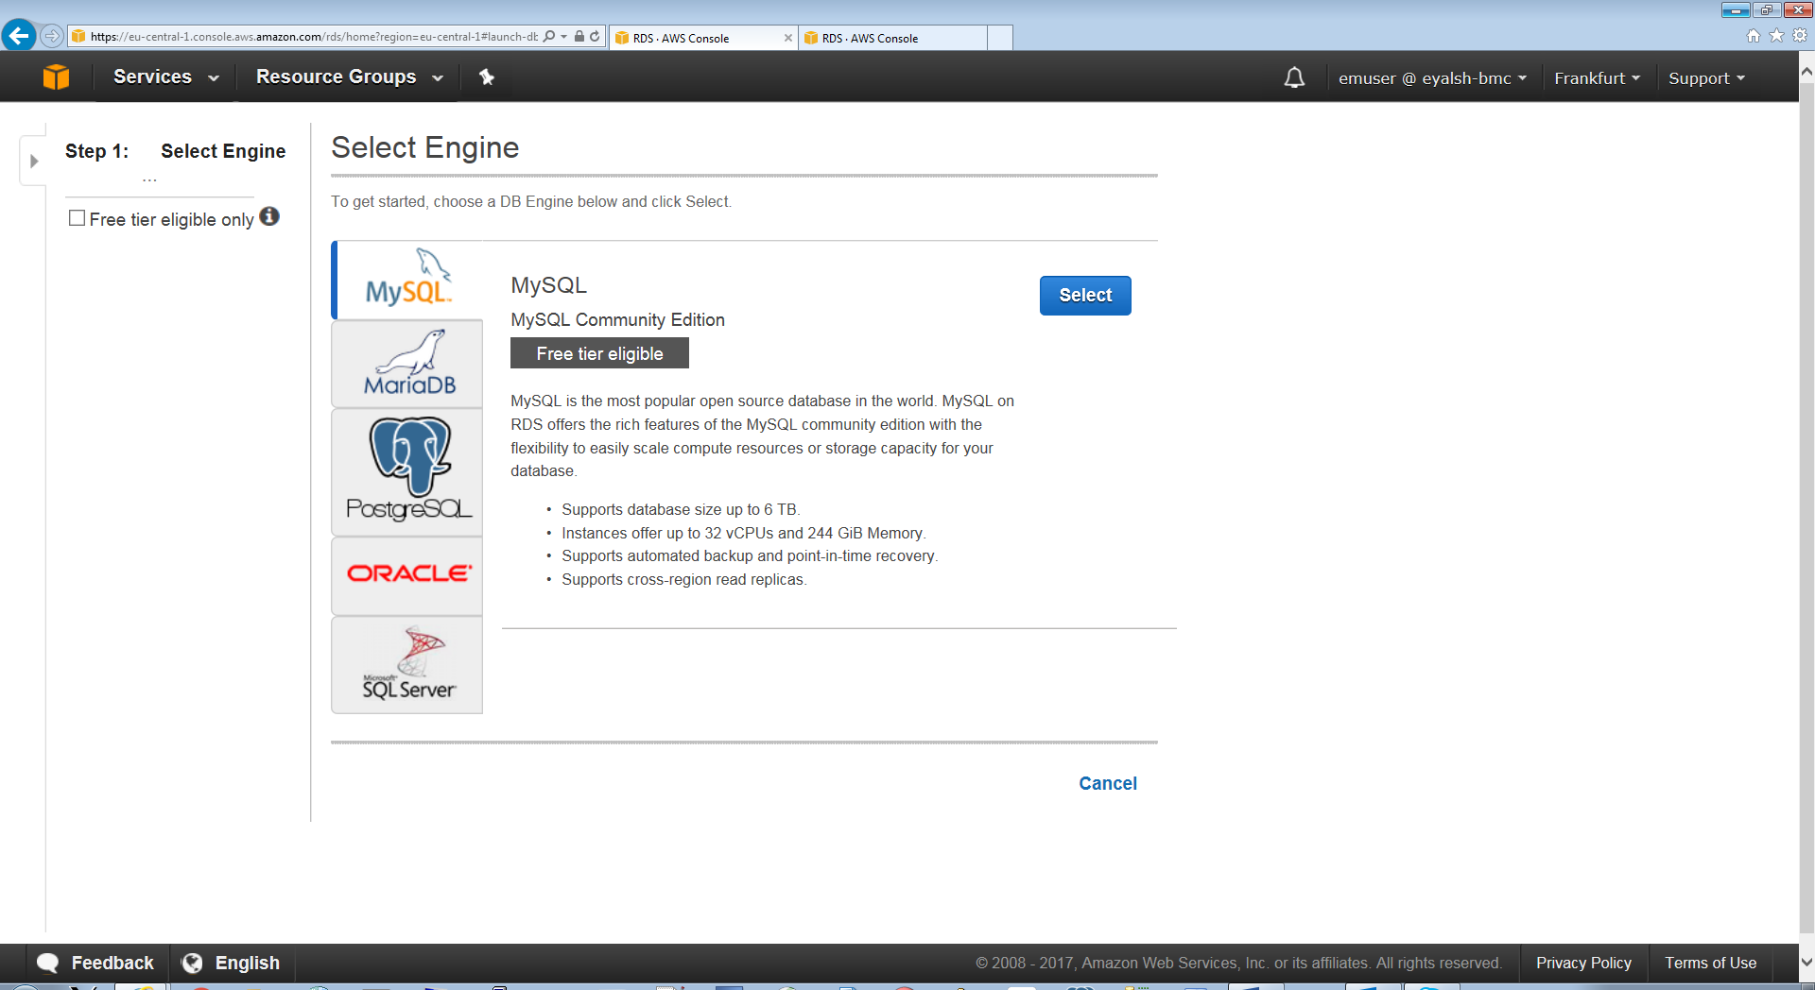

PG – Step #1
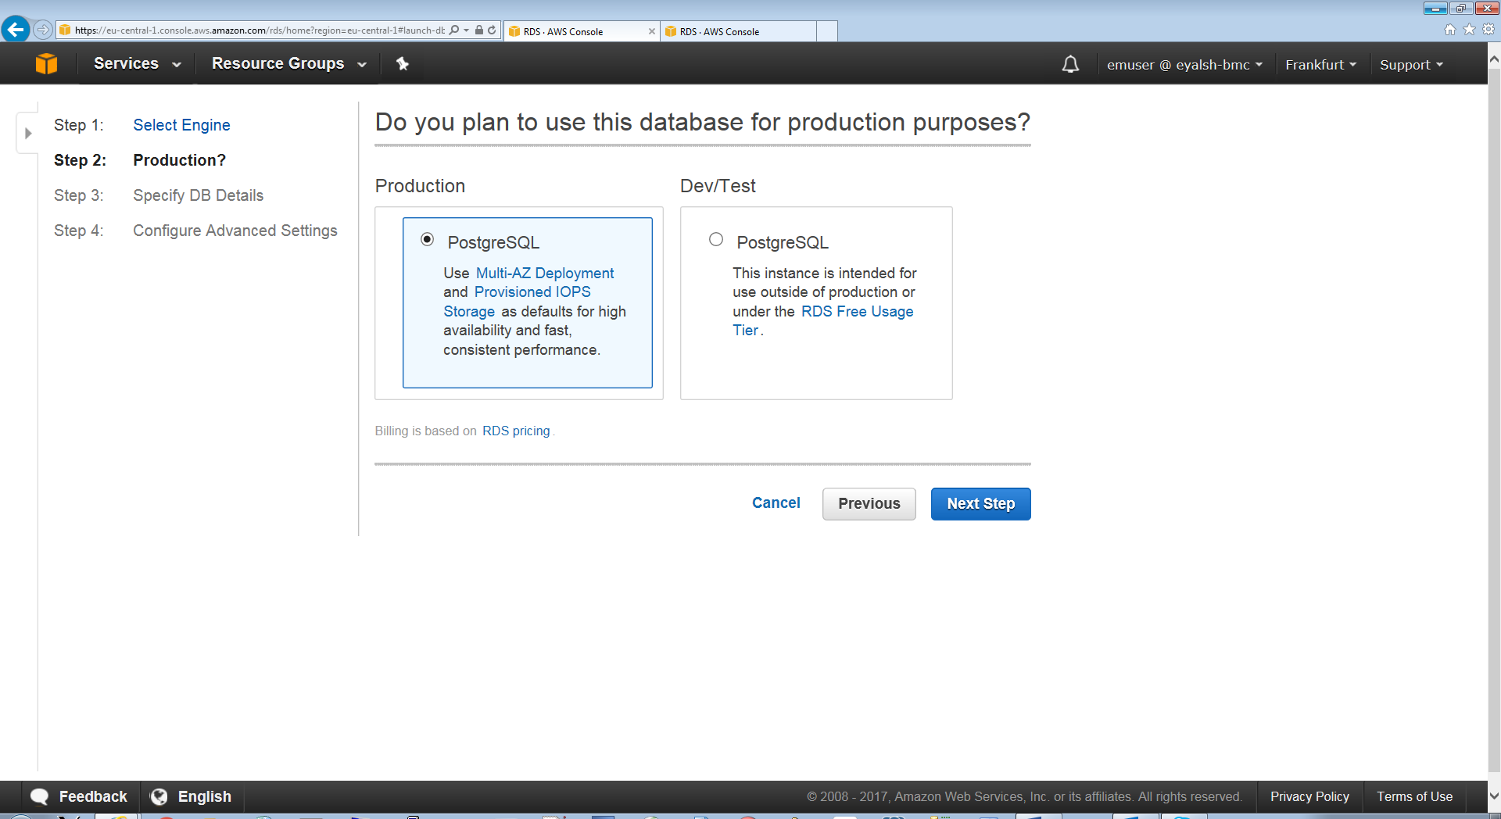

PG – Step #2

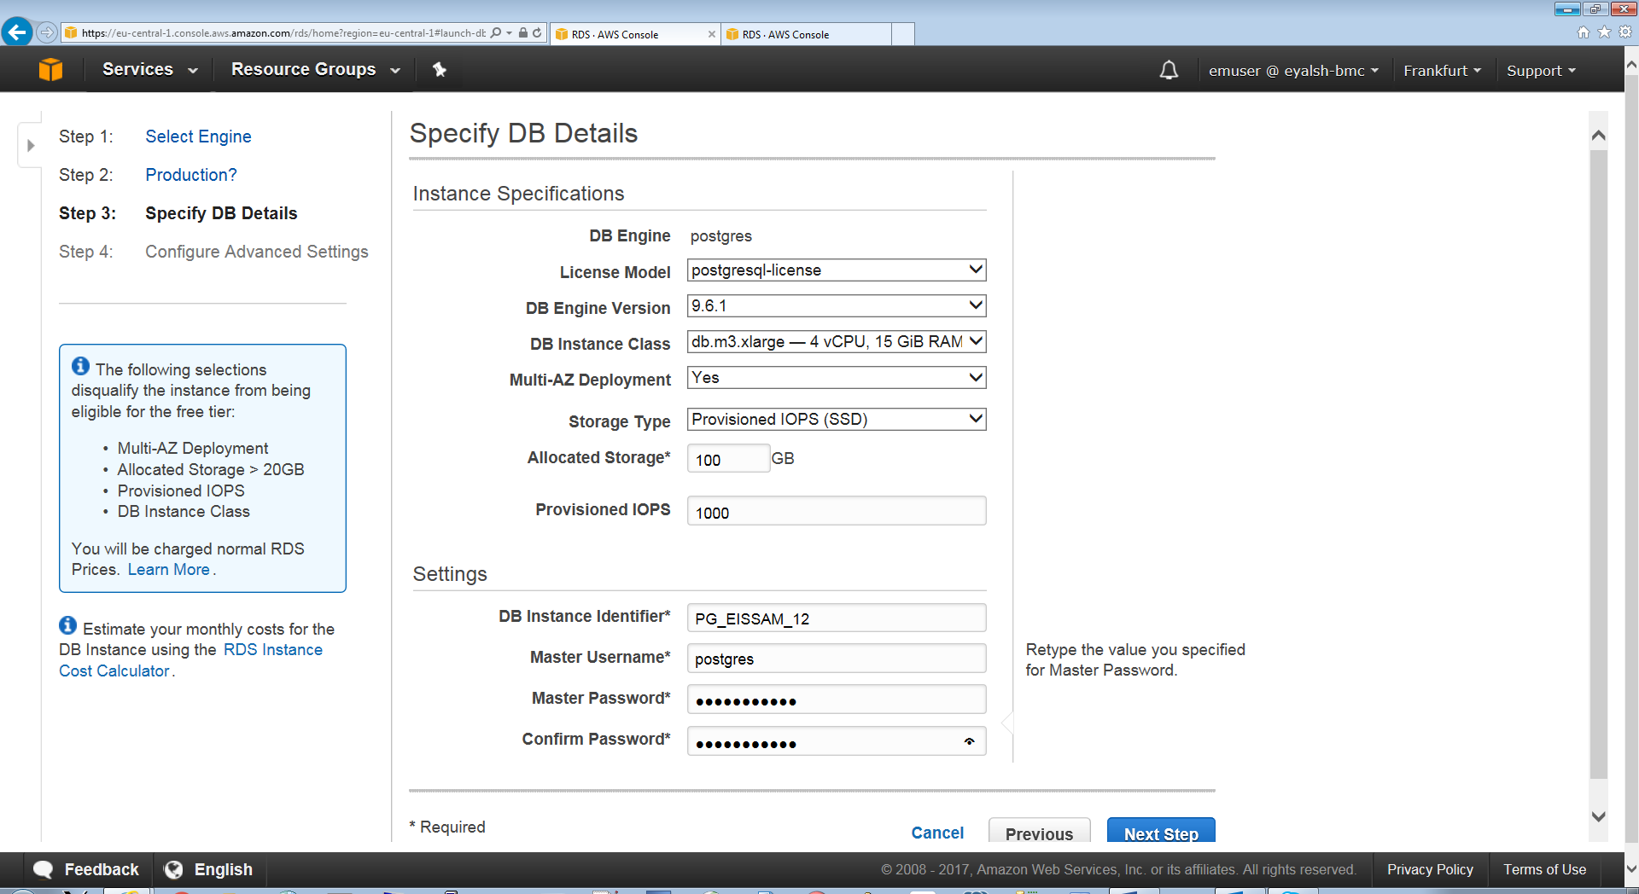

PG – step #3
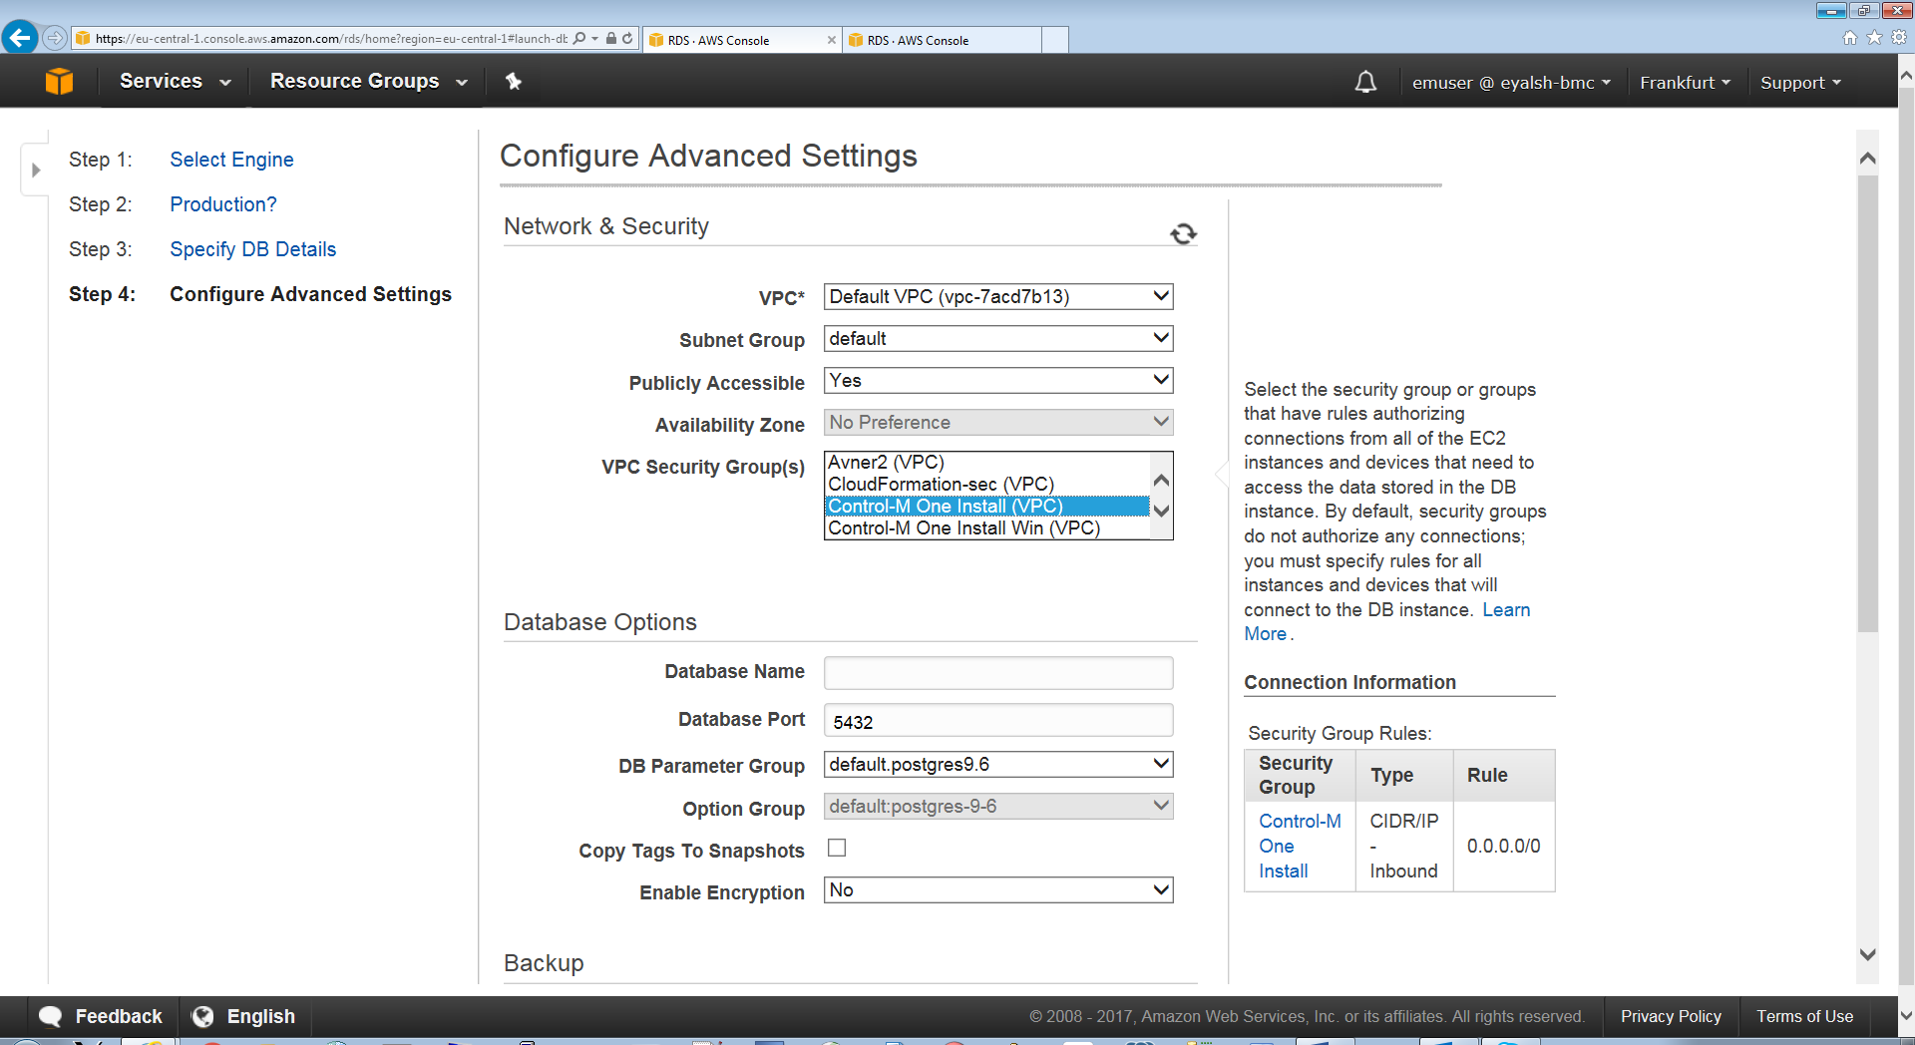

PG – final
End point: pg-eissam-2.crdt6hbncc0h.eu-central-1.rds.amazonaws.com
Port: 5432
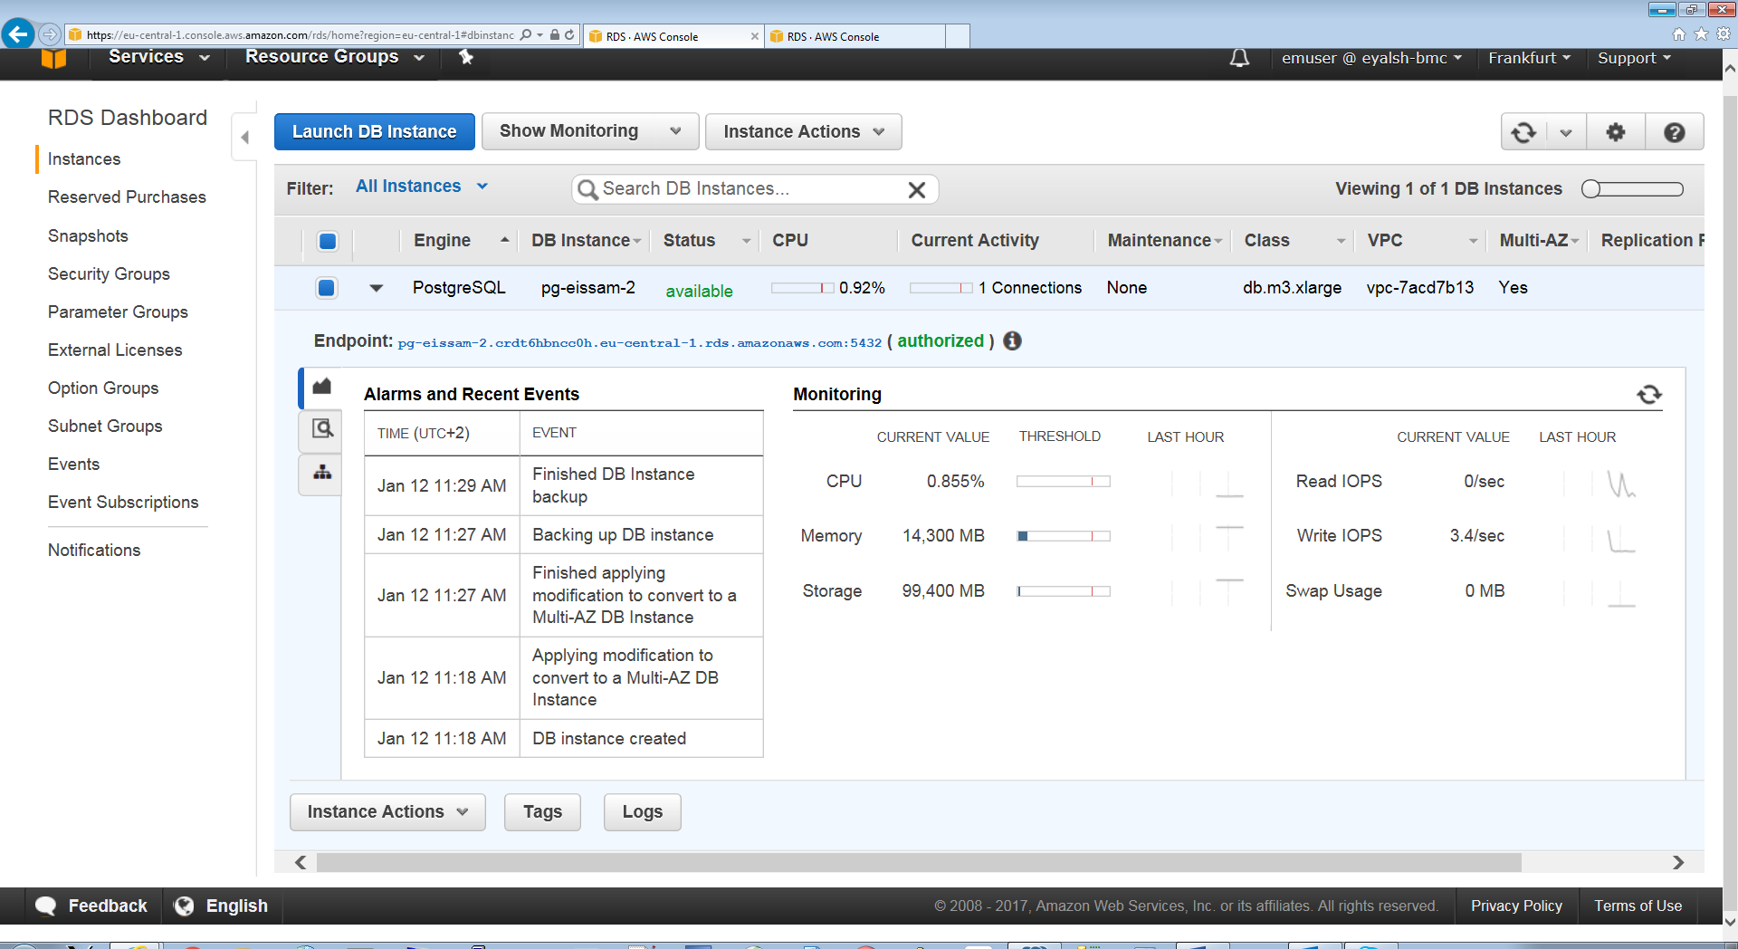

Oracle – step #1
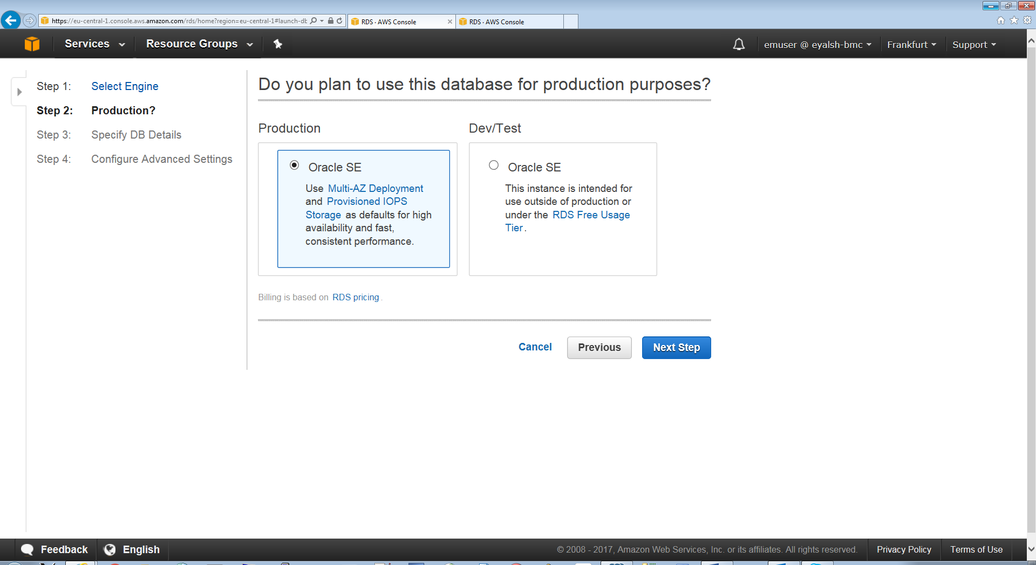

Oracle – step #2
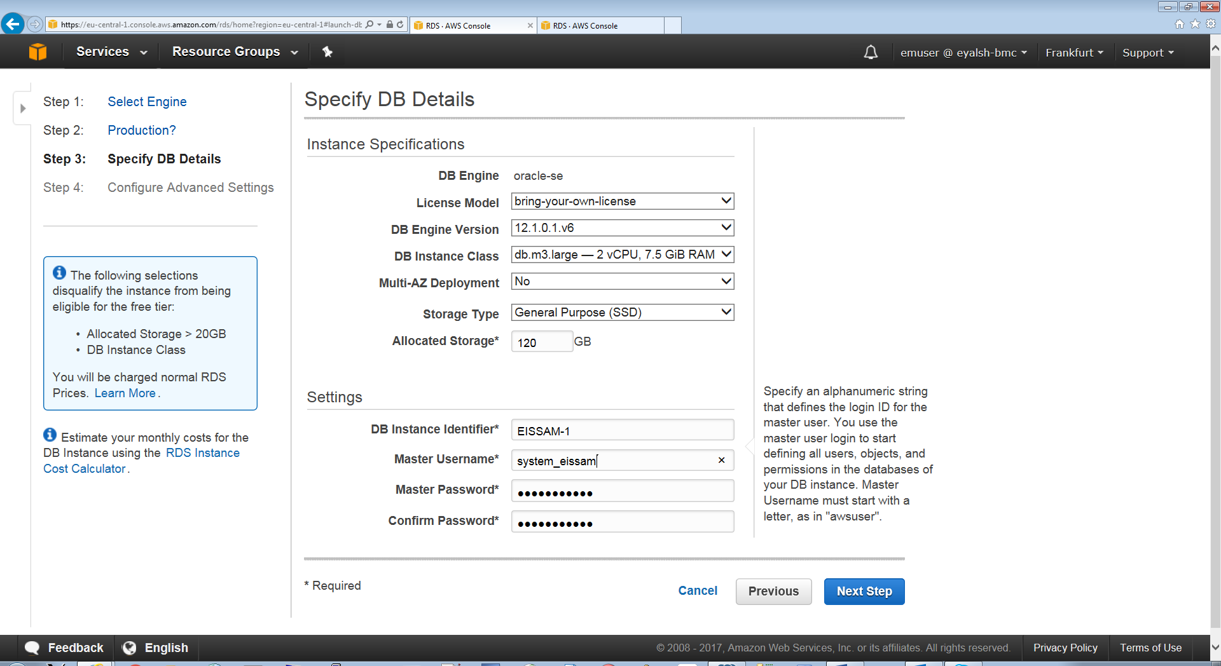

Oracle – step #3
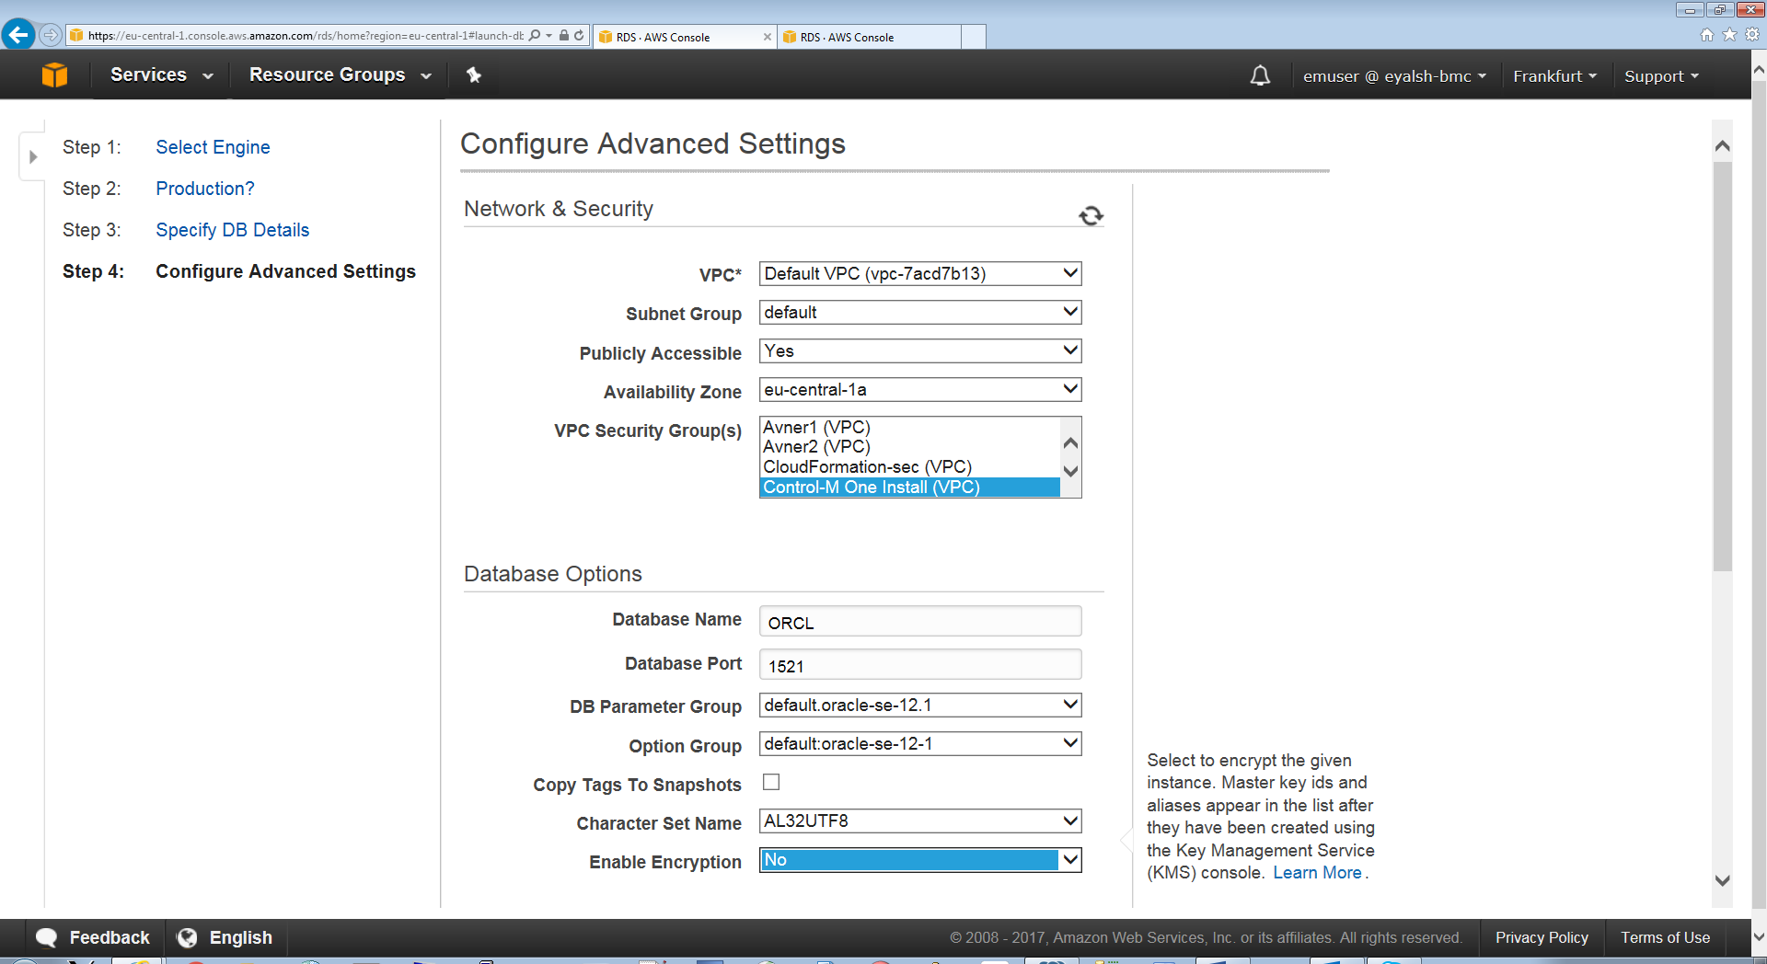

Oracle – final
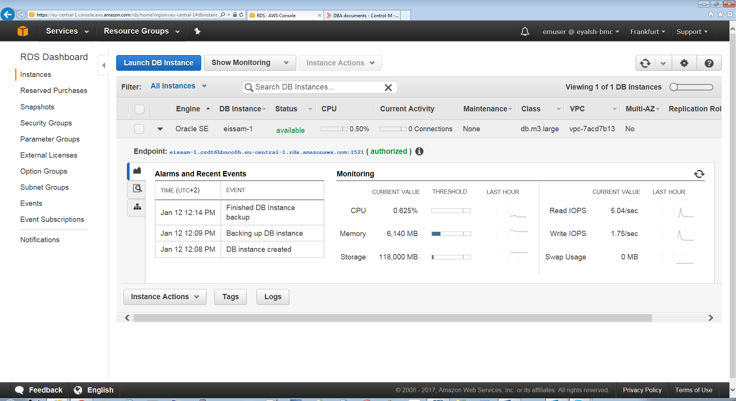
End point - eissam-1.crdt6hbncc0h.eu-central-1.rds.amazonaws.com
Port: 1521
MS SQL Server – Step #1
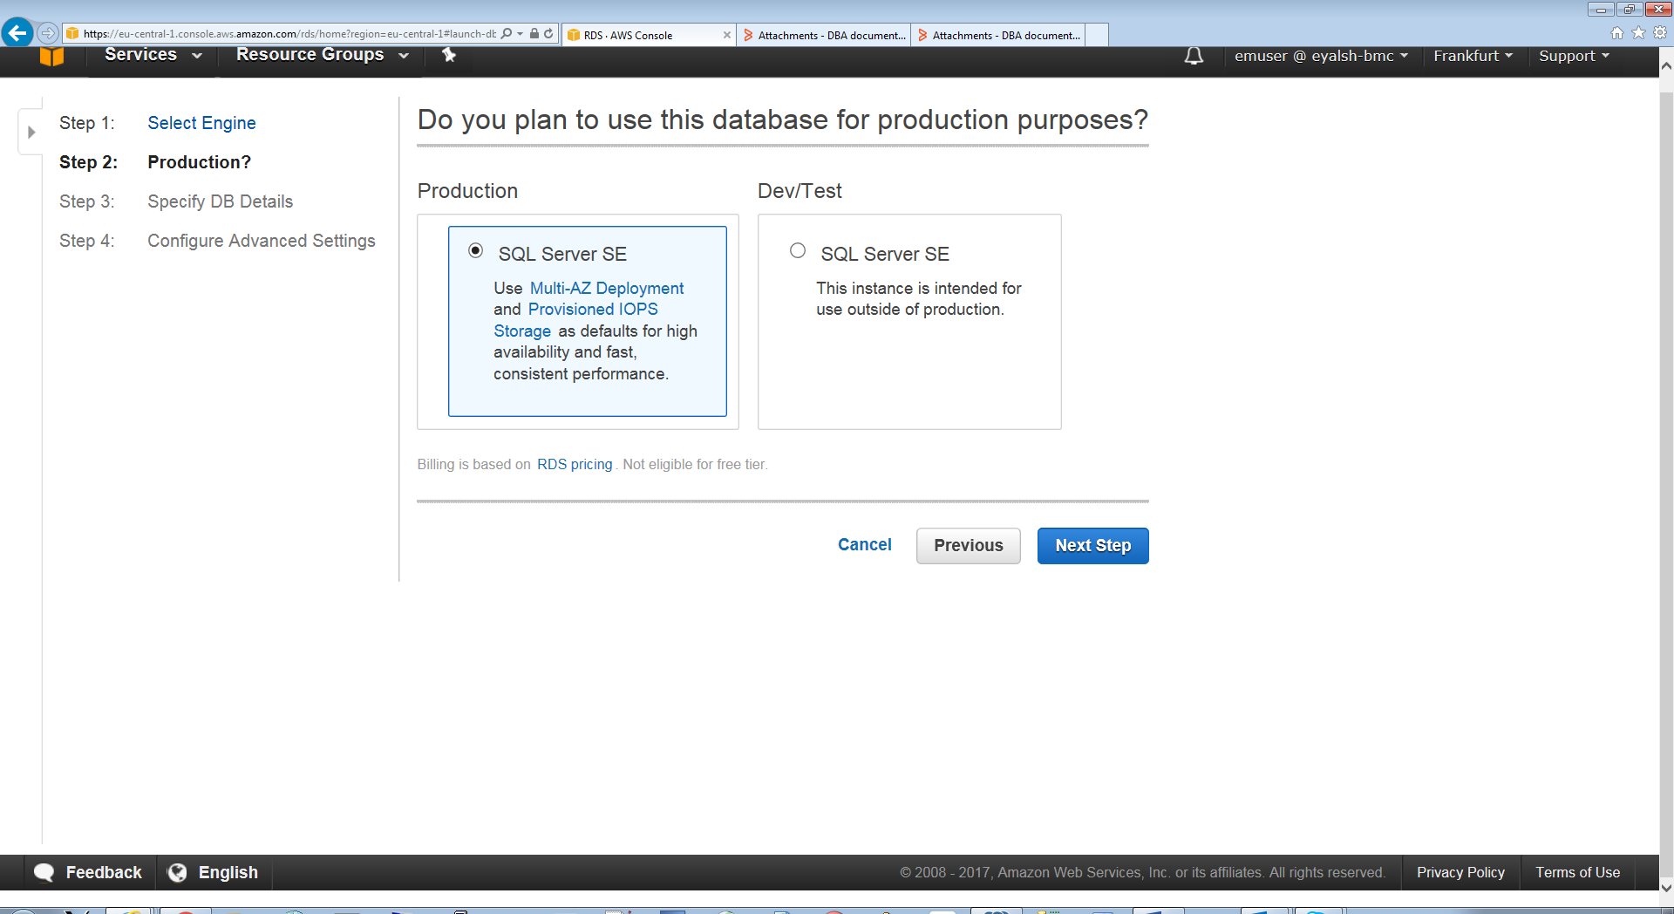

MS SQL Server – Step #2
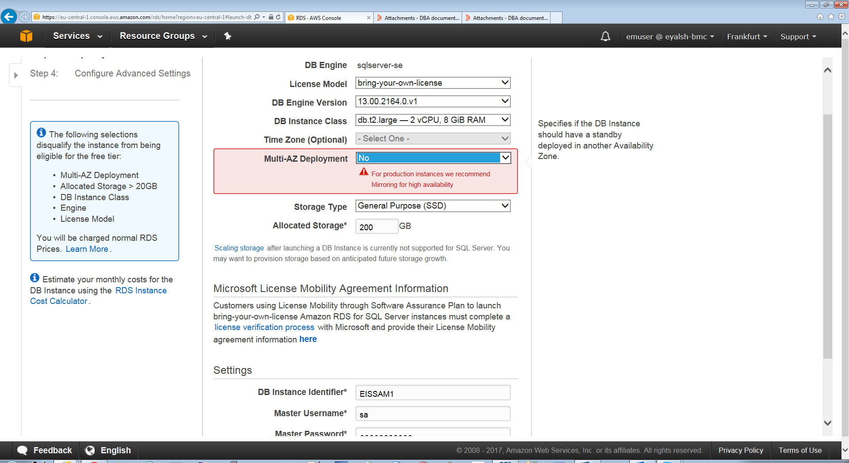

MS SQL Server – Step #3
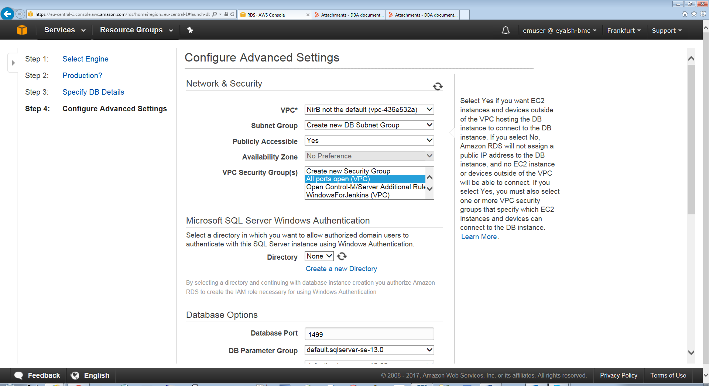

MS SQL Server – final

